 **Calcium Channel**

**Blockers**

**Amlodipine**

Anti-hypertensive L-type calcium channel blocker. Amlodipine has a longer duration of action as compared to other similar calcium channel blockers.1

Product No: 10-1210 250 mg/$30.00 500 mg/$55.00

**Felodipine**

Felodipine is a potent L-type Ca2+ channel blocker that is selective over N-, R-, P/Q- and T-type channels.2,3

**Product No: 10-2020 10 mg/$50.00 50 mg/$120.00**

**Isradipine**

L-type calcium channel blocker. Displays anti-atherosclerotic effects and improves endothelium-mediated nitric oxide-dependent vasodilation.4 Displays neuroprotective activity in rat models.5

**Product No: 10-1202 10 mg/$64.00 50 mg/$256.00**

**Nicardipine HCl**

Nicardipine is a clinically useful L-type calcium blocker. Inhibitor of MDR.6

**Product No: 10-1201 50 mg/$30.00 250 mg/$50.00**

**Nifedipine**

Nifedipine is a clinically useful L-type calcium blocker.7

**Product No: 10-1116 1 g/$40.00 5 g/$122.00__**

**Niguldipine**

L-type calcium channel blocker, which can also inhibit T-type calcium channels at higher concentrations.8 Novel inhibitor of drug transport by p-glycoprotein.9

**Product No: 10-1215 10 mg/$64.00 50 mg/$250.00**

**Nitrendipine**

Nitrendipine is a clinically useful L-type calcium blocker.10,11

**Product No: 10-1216 50 mg/$75.00 250 mg/$200.00**

**Verapamil**

Clinically useful L-type calcium channel blocker.12 It is also used as an inhibitor of drug efflux pump proteins.13

**Product No: 10-1111 1 g/$27.00 5 g/$85.00____**

**Manidipine 2HCl**

Manidipine 2HCl is a clinically useful L- and T-type calcium blocker with high selectivity for vasculature.14,15

**Product No: 10-2045 20 mg/$30.00 100 mg/$60.00**

**TTA-P2**

TTA-P2 is a potent, specific, and reversible T-type calcium blocker.15

**Product No: 10-3993 5 mg/$50.00 25 mg/$175.00**

**Nilvaldipine**

Novel L-type calcium channel blocker that also blocks Syk.16

**Product No: 10-3035 50 mg/$70.00 250 mg/$250.00**

**Diltiazem HCl**

Diltiazem is a non-dihydropyridine L-type calcium blocker.17

**Product No: 10-1139 1 g/$50.00 5 g/$140.00___**

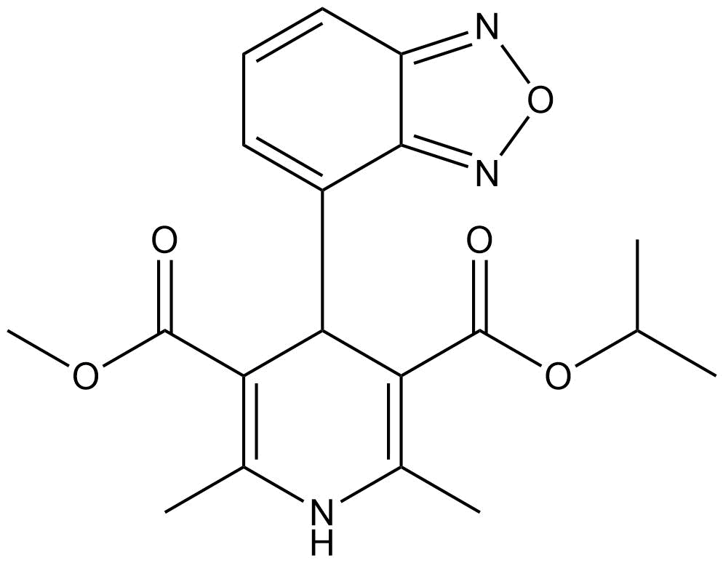

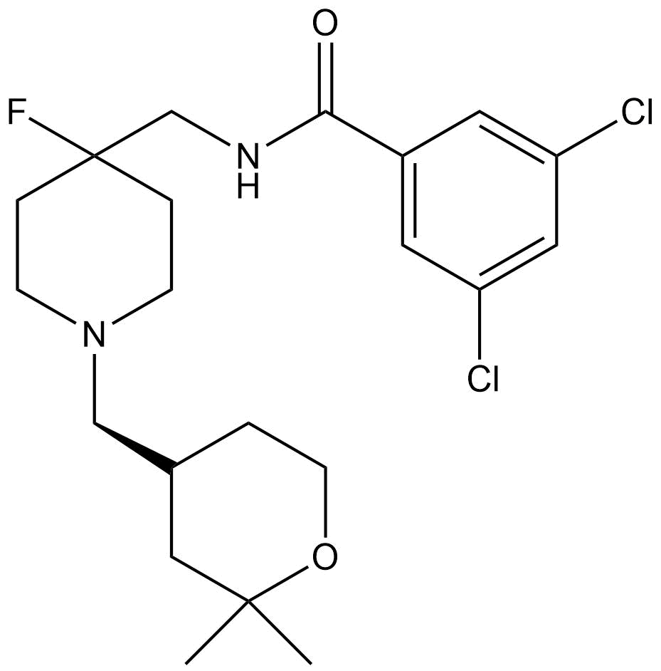

**TTA-P2**

**REFERENCES**

1. Ueda *et al.* (1993) Br. J. Clin. Pharmacol., **36** 561
2. Todd and Faulds (1992) Drugs, **44** 251
3. Furukawa *et al.* (1999) J. Pharmacol. Exp. Ther., **291** 464
4. Bracht *et al.* (2001) J. Hyperten., **19** 899
5. Chandra *et al*. (1999) Pharmacology, **58** 292
6. Hulubei *et al.* (2012) Bioorg. Med. Chem. **20** 6620
7. Vater *et al.* (1972) Arzneimitteforschung **22** 1
8. Stengel *et al*. (1998) Eur. J. Pharmacol., **342** 339
9. Holit *et al.* (1992) Biochem. Pharmacol., **43** 2601
10. Meyer *et al.* (1981) Arzneimittelforschung, **31** 407
11. Stoepel *et al.* (1981) Arzneimittelforschung **31** 2056
12. Brogden and Benfield (1996) Drugs, **51** 792
13. Kakihana *et al.* (1988) Jpn. J. Pharmacol., **48** 223
14. McKeage *et al.* (2004) Drugs, **64** 1923
15. Shipe *et al.* (2008) J. Med. Chem., **51** 3692
16. Paris *et al.* (2014) J. Biol. Chem., **289** 33927
17. Kraus *et al.* (1998) J. Biol. Chem., **273** 27205

**Isradipine**